LAB LOCATION: | AZADI CO., LTD | REPORT NUMBER: | 221004-P10A
DATE IN: | Aug. 25, 2022 | DATE OUT: | Sept. 25, 2022

Applicant: | AZADI CO., LTD |  |  |  | OVERALL RATING
Address: | No.518, To Ngoc Van Street, Tam Phu Ward, Thu Duc City, HCMC, Vietnam
Contact: | Mr. Vuong |  |  |  | PASS | -
Contact: |  |  |  |  | FAIL | -
TEL: | 0979790959 | FAX: | - |  | DATA | X
E-mail: | vuongtm@azadi.vn
Copy To: | -

Sample Information
Sample Description | Azadi Powder Desiccant 1kg / bag for container dry
Style Number | -
Quantity | - | PO Number |  | -
Buyer’s Name | - | Manufacturer |  | AZADI CO., LTD
Country of Origin | Viet Nam | Country of Destination |  | -
Code Number | - | Dept/Key# |  | -
Reference item/ style number | - | Color |  | -
Testing Status
Pre-Shipment Lead Test |  | Test for Protocol | -
Retest | Previous Report No.: -

Sample Photos
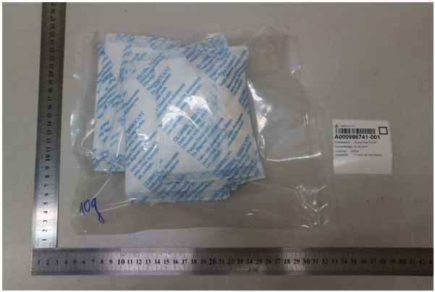
221010-P1K

Report Number: 221004-P10A

EXECUTIVE SUMMARY:

TESTING RESULT SUMMARY
Test Property | PASS | FAIL | DATA | COMMENTS
Desiccant moisture absorption | - | - | X | -

Client’s Requirements:

TEST ITEM | TEST METHOD | TEST REQUIREMENT | RESULT
Desiccant moisture absorption | MTS In-house method  H-41007 (Mod) | 20 days at 90% R.H and 40ºC Note: Testing was performed as per client’s request. | DATA  Before test: 1013.20g After test: 2101.71g Weight increase:  (+108%)

Report Number: 221004-P10A

If there is question or concern regarding the above results, please contact the appropriate lab person below: Technical questions:
Primary Contact: James Nguyen | Tel: +84-28-6289-6363 Ext: 173 | Email: jamesnguyen@mts-global.com
Back-up Contact: Harry Vu | Tel: +84-28-6289-6363 Ext: 175 | Email: harryvu@mts-global.com

Concerns About Billing and General Inquiries:
Primary Contact: Vincent Pham | Tel: +84-28-6289-6363 Ext: 114 | Email: vincentpham@mts-global.com
Back-up Contact: Sophia Nguyen | Tel: +84-28-6289-6363 Ext: 107 | Email: sophianguyen@mts-global.com

This test report is governed by the Terms and Conditions, available on request or accessible at http:/www.mts- global.com/en/terms.html. Attention is especially drawn to the limitations of liability, indemnification and jurisdictional provisions defined therein. This report is issued strictly based on the testing of the samples submitted by you. The test results in this report refer only to the sample(s) actually tested and do not refer or be deemed to refer to any bulk production from which such sample(s) may be said to have been obtained. In the event that MTS was requested to survey and test any bulk production quantity of samples, MTS, in the absence of any contrary written instructions, performed random sampling of bulk production for testing purposes. Variations in the conditions under which samples are stored, transported, etc., may lead to variations in the test results. MTS cannot anticipate and shall not be held responsible for variations in test results that may be due to factors beyond MTS’ control, such as, sample cross-contamination, evaporation of volatile substances due to storage temperature, humidity, etc. This report does not constitute a recommendation, actual or implied, for any specific course of action. Other than the expressed warranties made in the Terms and Conditions of the MTS Test Request Form, MTS makes no warranties or representations either express or implied with respect to this report. In no circumstances whatsoever shall MTS be liable for any consequential, special or incidental damages arising out of, or in connection with, this report.

